Designing New Experiences at PSU
IS 4220.01 Team
Alexis Fagan, Sam Knapton, Julie Nagel, Alie Louie, Megan Toman

Table of Contents

Summary 3
Our Problem 3
Problem Description 3
Problem Scope 4
Technical Review 4
Design Requirements 4
Design Description 4
Overview 4
Figure One: Main Menu of the “Interactive Journey Map” 5
Design Decisions 5
Ethical Considerations 6
Evaluation 7
Overview 7
Prototype 6
Figure Two: The First Prototype 7
Figure Three: Combining Our Individual Creations. 7
Figure Four: 8
Figure Five: Final Draft of the Interactive Journey Map. 8
Next Steps 9
Conclusion 10
Acknowledgements 10
References 11

Summary

High school students who are interested in pursuing higher education have a lot of information they need to read and understand in order to apply to, be accepted to, enroll in, and register for classes in college. In other words, we want to help high school students find their right fit college. All of this information can be overwhelming for not only the prospective students, but for their guardians as well, and it doesn’t help that the current Plymouth State University (PSU) website has the information scattered all over.

We developed a set of web pages that gives the necessary information to all prospective students and guardians. We call this set of pages an “Interactive Journey Map”. Our design decisions included using simple language, avoiding replication of information found on the website, but instead providing hyperlinks to the PSU website, using PSU branding, and making sure navigation was easy and clear.

Next steps include finding someone who is able and willing to take over the maintenance of this project. In addition, the web pages need to be tested with real prospective students and their guardians.

Our Problem

Problem Description

In January of our Spring 2019 semester, our Signature Project class sat down with Professor LeBlanc and set our goals for the Signature Project. Our course was specifically made to explore "design" and what makes a good design. We were also charged with evaluating and improving the existing onboarding experiences for potential incoming Plymouth State University (PSU) students. By onboarding experiences, we mean inquiry, application, admittance, enrollment, and registration. While researching online and meeting with the Enrollment Management and Admissions team about what the pre-first year experience is like, we discovered a problem: prospective students have a lot of information to sift through, and finding the most relevant information for them on the PSU website is difficult.

Problem Scope

Although all incoming college students face this problem, we decided to focus on prospective first year students interested in coming to PSU. We focused on the general experiences every prospective student needs to consider participating in. For example, we didn’t include the experience of meeting with coaches because not every student will do that.

Technical Review

Today, there is a great amount of stress and anxiety levels surrounding the college application process. One stressor stems from high competition levels. Another stressor is the decrease of affordability of a college education, and also pressure from families to perform and get into a "well known" university.

The Admissions and Enrollment Management teams at PSU are aware how stressful applying to college can be, and have a couple designs in place to aid in the process. Admissions uses a tool called "Mongoose" to text students and parents about reminders for application deadlines. There are also various emails sent out to students and parents to inform them of the next steps to take within the application process. Our school website has various resources for prospective students to use at any step of his/her process. There are plenty of useful tools to help relieve some of the stress, but none where all the information is in the same place. That is where our design comes into play.

Design Requirements

- Information in the Journey Map is found in three or fewer clicks
- Journey Map is easy to navigate
- The Journey Map is PSU branded with colors, logos, photos, etc.
- Several hyperlinks are used in the Journey Map

Design Description

Overview

Our project is a visual “Interactive Journey Map” that guides prospective students through the general path of the college onboarding process. Our vision is that a prospective student would find it on the PSU website, and click through the stages that are most relevant to them. For example, there are five different stages a prospective student could be at in their process (Figure 1 shows the main menu of the “Interactive Journey Map”). Depending on their stage, that is what menu they would click. If a student is just in the beginning of the process, unsure if PSU is right for them, they would click the "I am Ready to Learn about PSU" menu, which would take them to a list of hyperlinked resources that would let them get a feel for PSU. If a student has already been accepted, they would click the "I am Accepted" menu, and find out what the next steps are.

Figure One: Main Menu of the “Interactive Journey Map”
This is the main menu of our interactive journey map that includes the five stages. Students would choose the most appropriate stage depending on where they are at in the onboarding process.
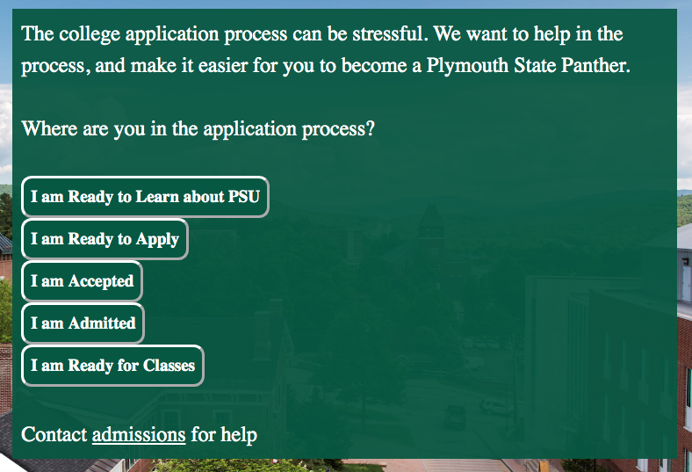

Design Decisions
- Used informal, simple language
- Remained as close as we can to the critical path
- Branded with PSU colors, logos, photos, etc.
- Created a main menu with five stages (I am Ready to Learn/I am Ready to Apply/ I am Accepted/ I am Admitted/ I am Ready for Classes)
- Decided to not replicate important information but provide a simplified version of that information and include hyperlinks to the details on the PSU website
- Included “back” and “main menu” buttons
- Included “speak with admissions” buttons
- Created final closing passage to signify the student has met all the steps along the critical path of the journey map
Use

Our interactive journey map will be used by prospective students of PSU. Guardians would also be able to use it, if they were curious about their child's next steps in the college onboarding process. The journey map could be accessed via computer or mobile device. Students would click on menus most relevant to them, and have options to click on hyperlink sources to find information regarding whichever stage of the application process they are in.

Ethical Considerations

The goal of this class was to make a product designed specifically for first year college students, so it was valuable to take into consideration the language used in our product. For prospective students who have little knowledge about PSU, it would be unethical to use aggressive language to make students feel forced to take further action. We decided that the language was to be passive, inviting, and considerate. By avoiding words or phrases such as, “have to complete”, “mandatory”, and “complete this step now”, misinterpretations of our Interactive Journey Map have been avoided.

Another ethical consideration discovered early on was to use understandable language and terminology for a first year college student. When we had conversations with the Enrollment Management and Admissions team on campus, they informed us that guardians and students can be confused by the onboarding experience terminology used on the website. By keeping the language simple, the Interactive Journey Map will be easy for students to comprehend.

The Interactive Journey Map was also designed so that information wasn’t needed from the user (i.e. name, email, phone number). This kept the project open to all who are curious about this school, without having to fully commit to getting emails or signing up for a mailing list. The product also did not directly ask users for money or time to the school. While some steps included in the Interactive Journey Map mention monetary or time commitment (deposit, visit us), it was simply a suggestion of how the individuals could get more involved at Plymouth State University.

Another ethical consideration was the disclaimer at the bottom of the main menu page. The disclaimer is stated as follows:

“DISCLAIMER: Every journey will look differently for every student. Although this outlines the main parts of what a student should typically do to get you successfully to your first day of classes, it might not be exactly catered to you.”

This was suggested to include in the design from the Enrollment and Management (Admissions) and the Marketing teams that evaluated the project. The disclaimer is a way to reduce the chance of a parent, guardian, or student comparing the journey map to what they have been told by others, or what they personally need to do individually. Although, the Interactive Journey Map is made specifically for first year students, it outlines the generalized steps it takes to become a PSU Student.

Evaluation

Overview

Our plan for evaluating our design was based on testing our prototypes. We created various prototypes, and critiqued them according to the feedback we received from the Admissions, MCCS and Student Enrollment teams.

Prototype

Figure Two: The First Prototype
We began by individually, creating a prototype for our sections. This is one of our student’s prototype for the "Inquiry" stage, which was later renamed because of the confusing terminology.

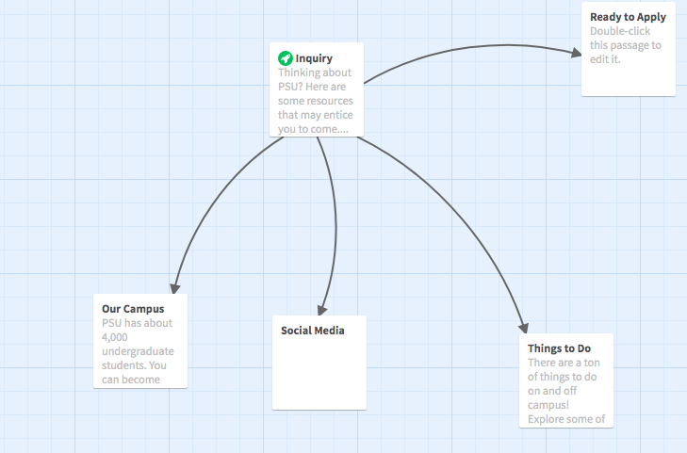

Figure Three: Combining Our Individual Creations.
Our next step was to put our prototypes together, and make one journey map. This was the first look at combining all the different steps together into a powerpoint.
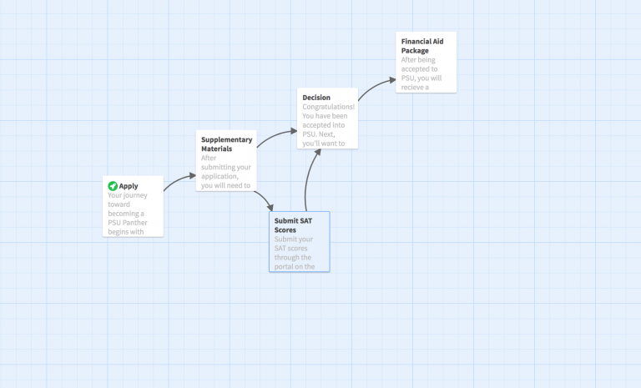

Figure Four:

After testing our prototype, we realized there were still some sections to add, Our next phase was to add all the needed information to build our final prototype.
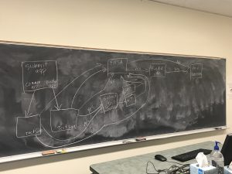

Figure Five: Final Draft of the Interactive Journey Map.
After many group collaboration sessions, this is our final product.

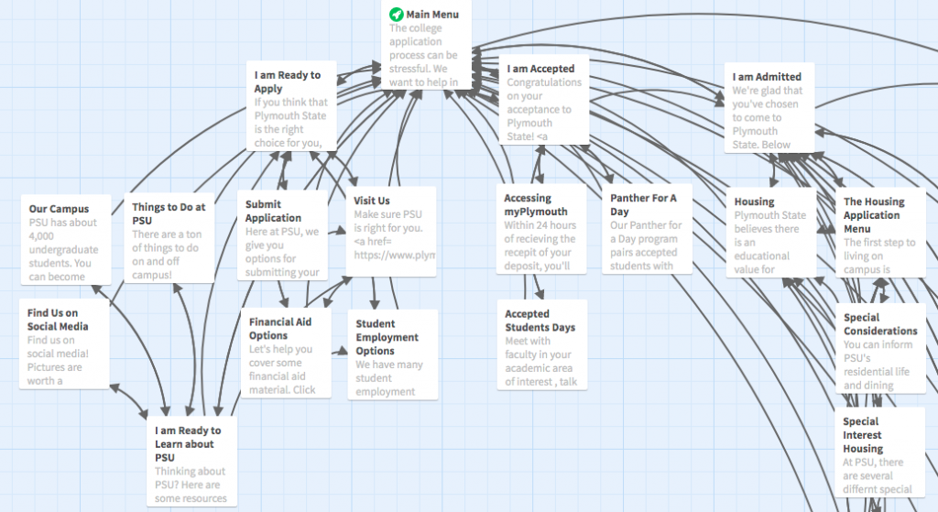

The design process is iterative. It took us many trials and errors to put together our final journey map. It started out from post-it notes on the board, to stories on the application "Twine", to reorganizing our work on the chalkboard, and then many presentations to the Student Enrollment team, Admissions, and MCCS. From that process is how we came to our most final edition of the journey map.

Next Steps
Now that the semester is coming to an end, we do not want our work to just disappear. We want to see our interactive journey map be implemented in the first year student experience here at PSU. In order to see our work through, there are still a couple things left to do.
- Solicit feedback about the journey map's simplicity (prospective students, parents, etc.)​
For future work, the journey map should be tested by prospective students, and
other current PSU students and staff ideally on a large scale. By receiving as
much feedback as possible, then the journey map can also be assessed for its
strengths and areas for improvements.

- Decide where the journey map will be within the PSU website​
- Determine someone who will be responsible for maintenance of the journey map ​
- Expand the journey map to include the critical path for transfer students and other groups​

Conclusion
What we have created over the course of this class is the foundation of an innovative and useful process that Plymouth State University can use to help those interested in coming to their school, but could not figure out where to find the information they needed. From reading about design, to meeting with professional university staff members, and to creating and implementing our own design decisions, we have been able to begin a design application that could support the application process for prospective students.

Incorporating our project as part of the official Plymouth State website for the use of prospective students and their families is one of the next steps for this long-term project we introduced to the university just some months ago. The ideal person to take over this project would be someone who works on updating the Plymouth State website frequently, cares about the content of the website, and understands and respects the purpose of this project that we have begun.

Acknowledgements

We would like to thank Hannah Adritsakis, Jason Moran, and Matt Wallace with Enrollment Management, Meghan Merit-Schaffer with Student Success, and Marlin Collingwood, Corey Hoyt, and Morgan Navarro with Marketing Communications and Creative Services for meeting with us and giving us constructive feedback to help us complete this project.

References

How to Write a Design Report (Rep. No. 2015-2-17-2). (n.a.). (n.d.). Retrieved from http://www.me.umn.edu/education/undergraduate/writing/How-to-write-a-Design-Report.pdf

Easing College Admissions Anxiety by Understand Important Stats. Wilde, M. (2018, July 5).
Retrieved from https://www.greatschools.org/gk/articles/easing-college-admissions-anxiety/

